Experimental and numerical study of the laser transmission welding between PA6/sepiolite nanocomposites and PLA

José Ángel Moya-Murianaª, África Yebra-Rodriguez^{b}, M. Dolores La Rubia^{c}, Francisco J. Navas-Martos^{a,*}

ªPlastic Technological Centre, Andaltec, Avda. Principal s/n, Ampliación Polígono Cañada de la Fuente, 23600 Martos Jaén, Spain.
^{b}Department of Geology, Faculty of Experimental Sciences, University of Jaén, Campus Las Lagunillas s/n, 23071 Jaén, Spain.
^{c}Department of Chemical, Environmental and Materials Engineering, Higher Polytechnic School of Jaen, University of Jaen, Campus Las Lagunillas s/n, 23071 Jaén, Spain.

*Corresponding author.
E-mail address: francisco-javier.navas@andaltec.org

Abstract
PA6/sepiolite nanocomposites have been manufactured at different wt% sepiolite loading and a fixed minimum load of a IR absorber additive (CAA). Nanocomposites were characterised and welded with PLA specimens through transmission laser welding technology (TLWT). Resulting welded specimens were also characterised. Experimental data obtained from the characterisations were introduced and processed in a Computer-Aided Engineering (CAE) software to obtain a suitable fracture model based on cohesive zone model (CZM) and capable of predicting the behaviour of the nanocomposite/PLA welds against shear forces. A correlation analysis was performed to assess the goodness of fit between the experimental and simulation data.

Keywords: nanocomposites; laser; welding; simulation; CZM.

Abbreviations
CAA: Commercial Absorber Additive.
CAD: Computer-Aided Design.
CAE: Computer-Aided Engineering.
CMT: Cold Metal Transfer.
CZM: Cohesive Zone Model.
DCB: Double Cantiveler Beam.
DSC: Differential Scanning Calorimetry.
FEA: Finite Element Analysis.
FTIR: Fourier Transform Infrared.
FT-NIR: Fourier Transform Near-Infrared.
GRFP: Glass Fibre Reinforced Polymer.
HDT: Heat Deflection Temperature.
IR: Infrared Radiation.
LWT: Laser Welding Technology.
MCT: Mercury Cadmium Telluride.
MD: Molecular Dynamics.
MELAS: Multilinear Elastic material model of ANSYS.
PA6: Polyamide 6.
PA66: Polyamide 66.
PLA: Polylactic Acid.
PMH: Polymer Composite-Metal Hybrid.
S: Sepiolite.
SC-XRD: Single Crystal X-ray Diffraction.
SEM: Scanning Electron Microscope.
TB: ANSYS command to activate a date table for material properties input.
TLWT: Transmission Laser Welding Technology.
Tm: Melting temperature.
VCCT: Virtual Crack Closure Technique.
wt%: Weight percentage.
XRD: X-Ray Diffraction.
1D: One-dimensional space.
2D: Two-dimensional space.
3D: Tri-dimensional space.

Nomenclature
A | Absorbance
c_{c} | Heat capacities of composite
c_{f} | Heat capacities of filler
c_{p} | Heat capacities of matrix
C1 | Material constant 1 of the CZM
C2 | Material constant 2 of the CZM
C3 | Material constant 3 of the CZM
e | Euler number
E | Elastic modulus
F_{shear} | Shear force
F_{shear}MAX | Maximum shear force
n | Local normal direction of the interface
r | Correlation coefficient
R | Reflectance
t | Local tangent direction of the interface
T | Traction on the interface
T_{n} | Normal traction at the interface
T_{r} | Transmittance
T_{t} | Shear traction at the interface
T_{t1} | Traction component 1 in the element tangential plane
T_{t2} | Traction component 2 in the element tangential plane
u | Clamp displacement
u^{BOTTOM} | Displacement of the bottom surface of interface element
u^{TOP} | Displacement of the top surface of interface element
v_{c} | Specific volumes of composite
v_{f} | Specific volumes of filler
v_{p} | Specific volumes of matrix
W_{c} | Crystallinity indices
δ | Displacement jump of the interfacial separation
δ_{n} | Displacement jump in local normal direction
δ_{t} | Displacement jump in local tangent direction
δ_{t1} | Shear separation component 1 in the element tangential plane
δ_{t2} | Shear separation component 2 in the element tangential plane
$${\bar{δ}}_{n}$$ | Normal separation through the interface with normal traction being the maximum
$${\bar{δ}}_{t}$$ | Shear separation through the interface with shear traction being the maximum
ε | Strain
ε_{tB} | Strain at break
ε’ | True strain
λ_{c} | Thermal conductivities of composite
λ_{f} | Thermal conductivities of filler
λ_{p} | Thermal conductivities of matrix
Ø | Sepiolite volume fraction
σ | Stress
σ_{M} | Tensile strength
σ_{max} | Maximum normal traction
σ_{y} | Yield stress
σ’ | True stress
Φ(δ) | Surface potential

1. Introduction

Okada and Usuki [1] consider polymer/clay nanocomposites as advanced materials which have achieved exceptional interest in engineering since the first successful hybrid (polyamide6/montmorillonite) obtained by Toyota in the late 80’s of the past century. Review accomplished by Ali et al. [2] shows that intensive research has been carried out in this field due to the improved technical properties with respect to the counterparts or to those polymer composites manufactured by using conventional reinforcements.
Polyamide6 (PA6) is a semi-crystalline polymer extensively used in industry due to its great strength, toughness and wear resistance. Moreover, its interest in the manufacturing of clay reinforced nanocomposites has been increasing due to its large number of current technical applications [3].
The main feature of the PA6 structure is the manner in which polymer chains are organised interacting through hydrogen bonds forming flat sheets (lamellae) held together in the three-dimensional lattice by means of van der Waals interactions. According to Bunn and Garner [4] PA6 crystallises in three possible structures: α, γ and an intermediate state between the first two, β. Murthy [5] specifies the structural differences in these structures (polymer chain packing during crystallization and hydrogen bond length) yield different polymer technical properties.

It has been remarked by Fukushima et al. [6] that the crystal habit and arrangement of the clay are crucial to control the arrangement of the nanocomposite and hence the resulting technical properties. Results obtained by Fernandez-Barranco et al. [7] elucidate that fibrous shape silicates (e.g. sepiolite) in polyamide/sepiolite nanocomposites interrupt the polymeric lamellar superstructure and render the gap between the polymer chains inside a lamella further uniform through a reticulated semi-crystalline arrangement. In this model the sepiolite and the PA66 matrix are linked by stable hydrogen bonding between the amide groups of the polymer and the Si-OH groups of the fibrous clay. As mentioned by Yebra-Rodrigez et al. [8] epitaxial mechanisms explain the nucleation of the thermodynamically minus stable γ crystal phase in montmorillonite reinforced nanocomposites, which occurs in less extent in sepiolite reinforced nanocomposites. In addition to the crystalline structure, the research carried out by Da Paz et al. [9] confirms that crystallinity also affects thermo-mechanical properties in polymer/clay nanocomposites.

The laser welding technology (LWT) especially highlights in the joining of dissimilar materials, mainly because it introduces a set of crucial advantages: simplicity, efficiency, speed, precision, control, cleaning and adaptability [10, 11].

TLWT can operate by using different kind of laser sources, which generate laser beams whose wavelengths ranging from 0.8 μm-1.1 μm. This usually makes it necessary to add absorbent additives to the raw polymer to provide it with absorbent properties at work wavelengths. Some research about laser welding processes of polymer composites have been carried out [11, 12]. However, none of them involves PA6 as a composite matrix and Polylactic Acid (PLA) as a transparent part.

Predictive models of mechanical behaviour are increasingly used in engineering with the aim of reducing the time and the cost of new developments. ANSYS® Mechanical is a software solution for mechanical engineering that applies finite element analysis (FEA) to carry out structural studies. It covers a wide range of applications including stress and fracture simulations, among others.

Delamination or fracture along an interface is vitally involved in the ductility and toughness of multiphase materials. It has motivated substantial research on interfaces failure. Kendall [13] derived that crack deflexion is dependent mainly on the ration of interface and cohesive fracture energies for the material. Piggot [14] made evident that shear failure in matrix of composites is a tensile cracking process. Darveaux et al. [15] studied interface failure in lead free solder joints for a ductile-to-brittle transition strain rate. Xu and Wei [16] described the effect of various parameters on the load-bearing capability of the single lap joints subjected to tensile loading and showed that the evolution of the interface stress exhibits mixed-mode feature. Lin et al. [17] evaluated the shear strength and investigated the failure modes of cold metal transfer (CMT) welded lap joints for steel/Al. Taljera and Varna [18] focus on the modelling of failure mechanisms in composite materials with attention given to fibre/matrix debonding and delamination fracture. Li et al. [19] revealed that the failure mechanism of polymer composite-metal hybrid (PMH) specimens causes: a) debonding of the composite-metal interface, b) brittle thermoplastic matrix fracture, c) glass fiber breakage, and d) ductile failure of steel. Hansen-Dörr et al. [20] introduced a correction to the bulk failure standard phase-field to describe adhesive interfacial failure.

Methods based on conventional fracture mechanics, such as the crack growth energy release method, are able to model the interface delamination. Fujimoto et al. [21] proposed numerical techniques to simulate the crack propagation phenomena in fracture problems. Trädegård et al. [22] investigated whether remeshing and nodal relaxation capabilities could be used advantageously for elastic-plastic mechanical fracture. Shet and Deng [23] carried out orthogonal metal cutting process simulations where the chip separation was modelled with a stress criterion and a nodal release procedure. De Carvalho et al. [24] proposed an approach that combines progressive nodal release with virtual crack closure technique (VCCT) to model fatigue phenomenon in a mesh-independent fashion.

Alternatively, it is possible to introduce directly a fracture mechanism by assuming softening relationships between separations and tractions, which in turn add a decisive fracture energy, which is also the necessary energy to break the interface surfaces, model known as cohesive zone material (CZM). Wei and Hutchinson [25] proposed a traction-separation relation for peeling an elastic-plastic film joined to an elastic substrate and analysed the relationship of the peeling force with the adhesion force of the interface and its strength. Alfano and Crisfield [26] modified the mixed-mode delamination formulation in laminated composites to avoid the inconsistency of achieving complete delamination in modes 1 and 2 at a different time and established a generalised propagation criterion for the interface. Valoroso and Champaney [27] presented a cohesive interface model for simulating decohesion in adhesive-bonded assemblies using a single scalar damage indicator and a consistently defined energy release rate variable. Yan and Shang [28] compare three cohesive zone variants (trapezoidal, bilinear and trapezoidal) to simulate the interface delamination of the multi-layered piezoelectric thin films on a silicon substrate. Dandekar and Shin [29] carried out molecular dynamics (MD) simulations with the aim of integrating the traction separation law for an aluminium/silicon carbide interface in a CZM. Wu et al. [30] studied tilting separation analysis in bottom-up mask projection stereolithography using Mode I of crack opening and bilinear cohesive law. Gliszczynski et al. [31] dealt with double cantiveler beam (DCB) test of glass fibre reinforced polymer (GRFP) unidirectional laminates where the crack growth phenomenon was studied using the VCCT and CZM (bilinear and exponential) methods. Among the fracture analyses, we can find the Interface Delamination feature, which employing CZM method allows to define the failure criteria. In this way, the mechanical behaviour and the progressive separation between two dissimilar welded specimens that take place during shear tests can be also simulated, admitting of a comparison between experimental and simulated results when the CZM model used has been previously properly adjusted.

The objectives of this paper are (a) to study the impact of the fibrous clay sepiolite as reinforcing agent on the mechanical, thermal, crystallographic and optical properties of the resulting PA6/sepiolite nanocomposites; (b) to analyse the influence of nanoclay loading in the performance of PLA-PA6/sepiolite nanocomposites joins carried out by TLWT; c) to simulate the mechanical behaviour of the welds against shear forces by using CAE software; e) to establish a suitable fracture model for PLA-PA6/sepiolite nanocomposite/PLA welds against shear forces; f) to evaluate the goodness of fit between experimental and simulation results through a correlation analysis. For these purposes, six sets of PA6/sepiolite samples at dissimilar nanoclay content (0, 1, 3, 5, 7 and 9 wt%) and a fixed 1.64 wt% of CAA were manufactured by melt compounding, transformed by injection moulding in specimens and characterised. PLA pellets were also injected to get adequate samples to carry out the TLW processes. The resulting joins were characterised in terms of shear mechanical properties. Finally, the results obtained from the mechanical characterisations were used to simulate the behaviour of the welding during the shear tests by means of CAE software.

2 Material and methods
2.1. Materials and specimens
The PA6 nanocomposites were manufactured via melt intercalation as described in Fernandez-Barranco et al. [7], in a double screw extruder at 250 rpm and 240ºC. Commercial PA6 (Dinalon®75, Repol Group, Spain) and fibrous clay sepiolite organophillised with a protonated quaternary ammonium salt supplied by Tolsa S.A. (Spain) were used to obtain nanocomposite samples with different clay loading: 1% (PA6-S-1), 3% (PA6-S-3), 5% (PA6-S-5), 7% (PA6-S-7) and 9% (PA6-S-9). The raw PA6 (PA6-S-0 sample) was also extruded to ensure a stress and temperature treatment identical to that of the nanocomposites. PA6/sepiolite nanocomposites with 1.64 wt% of a specific CAA (Fabulase 350, Budenheim, Germany) were reprocessed through a internal mixer with twin-screw (Rehoscam, Scamex, France) under fixed processing conditions (185 s, 228 °C, 70 rpm) following the same procedure described at Fernandez-Barranco et al. [7]. Therefore, six different polymer nanomposites with absorbent properties were finally obtained: PA6-S-0CAA, PA6-S-1CAA, PA6-S-3CAA, PA6-S-5CAA, PA6-S-7CAA and PA6-S-9CAA. Subsequently, all these materials were transformed via injection moulding in a Babyplast 6/10 P Cronoplast machine at 60°C tool temperature and 250°C material temperature into different specimens: as specified by the standard procedures (UNE-EN ISO 527-2/1BA and UNE-EN ISO 75-2) and with appropriate geometry for TLW process (1 x 50 x 75 mm) respectively. Eventually, necessary PLA specimens (1 x 50 x 75 mm) for the TLW process were also manufactured from PLA (PLA HM1011, Hycail Oy, Finland) in the same injection moulding machine under specific processing conditions (40 °C tool temperature and 190 °C material temperature).

2.2. Materials Characterisation
Tensile properties were obtained in a 5kN MTS InsightTM Testing Machine equipped with extensometer. The resulting fracture surfaces were observed in a variable pressure SEM Leo 1430 VPSEM (Carl Zeiss, Germany). Differential scanning calorimetry (DSC) analysis were performed in a 822e Mettler Toledo (USA) under air flow (50 ml/mm), heating rate 5 °C/min over a temperature range of 25-300 ºC. Crystallinity indices (Wc) of PA6 crystals in the samples were determined as described in Mehta [32], as the coefficient of the enthalpy of melting (ΔHm) and that of a fully crystalline sample. Heat Deflection Temperature (HDT) of each sample was estimated as specified by the UNE-EN ISO 75-2/A120 standard procedure in a HDT/VICAT Plus Davenport tester (United Kingdom). XRD patterns were obtained in transmission mode SC-XRD Smart APEX D-8 Bruker diffractometer (Germany), under the following experimental conditions: MoKα radiation, 30 Ma filament current, 50 kV acceleration voltage, 0.5mm collimator diameter, 60mm distance to detector and 30s exposure time. The XRD2DScan Software, which is described in detail by Rodriguez-Navarro [33], was used to analyse the data. Optical characterisation of samples was carried out in terms of absorbance (A), transmittance (T_{r}) and reflectance (R) in the spectral range of 25000–7812 nm by a FT-NIR Analyzer spectrometer (Antaris, Nicolet, USA) in order to evaluate the feasibility of using these materials in the LTW process.

Mechanical, thermal and volumetric properties for those reformulated PA6/sepiolita nanocomposites with absorbent properties (PA6-S-XCAA) were determined as described in Navas-Martos et al. [34], by means of some approaches, data from material datasheets (provided by suppliers) and data from scientific literature. The values of clay thermal conductivity and heat capacity were obtained from Midttømme et al. [35] and Çelik-Karakaya et al. [36], respectively. The values of polymer thermal conductivity and heat capacity were obtained from Wen [37] and Chen et al. [38], respectively. The different approaches used have been as follow: (a) volume fraction linear mixing rule (Eq.1); (b) a series model (Eq.2) described by Hansen-Dörr et al. [20]; (c) mass fraction linear mixing rule (Eq. 3).

v_{c} = (1−Ø)· v_{p}+Ø· v_{f} (Eq.1)
λ_{c} = [(1−Ø)/λ_{p}+Ø/λ_{f}]⁻¹ (Eq.2)
c_{c} = (1−X)·c_{p}+X·c_{f} (Eq.3)
Where Ø is the sepiolite volume fraction; v_{f}, v_{p}, v_{c} are respectively the specific volumes of filler, matrix and composite; λ_{f}, λ_{p,} λ_{c} are severally the thermal conductivities of filler, matrix and composite; c_{f}, c_{p}, c_{c} are individually the heat capacities of filler, matrix and composite.
2.3. Welding process
The TLW processes carried out in this work were performed through a contour laser technology by using the Hybrid Welding Head 1.0 LPKF laser welding system (Germany), equipped with robotic arm IRB 1600-140 ABB (Switzerland) and tooling described in Navas-Martos et al. [34]. TWL procedure was carried out by using the same fixed values than those used in Navas-Martos et al. [34] in terms of optical (focal lengths of the lenses, laser spot diameter), track (type of path and length) and process parameters (pneumatic force, speed, auxiliary power and laser power). Finally, properly welded specimens with an overlap of 20 mm in length were performed for subsequent shear tests.
2.4. Weld seam characterisation
The shear strength of the joins was determined by using a universal testing machine H10KS (Tinius Olsen, USA) with two load cells 100 N and 100 kN and tooling displacement of up to 1100 mm. Shear tests were carried out as described in Navas-Martos et al. [34] by using a specific tools to grip the specimens appropriately, following a particular methodology based principally on the ISO 1465 standard which consisted basically in apply two equal forces (F_{shear}) in opposite direction on the welded specimen to create pure shear stress in the weld seam. Shear stress was caused by the upright displacement at 2 mm/min of the clamp in motion. Shear trials were considered completed once the weld failure took place and the maximum force supported by the weld (F_{shear}MAX) was determined. The result for each test is the average value of 5 samples.
A FESEM MERLIN high-resolution electronic microscope (Carl Zeiss, Germany) was used with the aim of studying: (a) the cross-section of accomplished welds; (b) the surface of the detached materials after carrying out the shear test of the welds. SEM images were performed in secondary electrons and backscattered electrons from samples suitably prepared with carbon coverage. The operating conditions were 20 kV and 2.1 nA.
Fourier Transform Infrared (FTIR) maps were performed to evaluate the surface of the weld seam resulting after welding failure in terms of the presence of PLA residues on the surface of the nanocomposite and vice versa. A Jasco IRT-7000 FTIR multi-channel microscope (Japan) equipped with a FTIR-6300 spectrometer was used. The under the operating conditions were MCT detector, reflection mode, 16X microscope objective, 4 cm⁻¹ resolution and 100 scans. Final maps of 15 x 50 points, 200 µm each, were obtained.
2.5. Tensile simulation
Simulations of the welded systems required a previous step which involved mechanical simulation of the tensile specimens to get the mechanical behaviour model of the each of PA6-S-XCAA, specifically in terms of true stress (σ’) - true strain (ε’) curves. This step was carried out following a specific procedure based on: (a) data obtained from experimental tensile tests and (b) tensile test simulations by means of ANSYS. The aim of the procedure was to get the true stress (σ’) - true strain (ε’) curves for each nanocomposite, in agreement with experimental tensile tests, to introduce them as input into simulation software for accurate definition of the materials behaviour in order to get appropriate results from the final simulations of the welded specimens.
Tensile tests simulations of the PA6-S-XCAA materials were completed following the UNE-EN ISO 527 standard and based on a 3D model of the specimen, design by means of CATIA software, with 3D elements of the SOLID186 (higher order 20-node solid) type and imposing the displacement of the clamp as a boundary condition. σ’ and ε’ consider the real (instantaneous) dimensions of the specimen at each moment during the tensile test. By the constancy in volume, the value of both parameters can be obtained from of the values of stress (σ) and strain (ε) previously determined experimentally by means of Eq.6 and Eq.7.
$σ'=σ\left(1+ε\right)$ (Eq.4)
$ε'=ln\left(1+ε\right)$ (Eq.5)
On the one hand, the previous methodology was used to get an elastic-multilinear curve referring to the tensile behaviour of each PA-S-XCAA specimen, which after being fitted by linear interpolation through the MATLAB software a mean curve was achieved for each percentage of sepiolite content. The Multilinear Elastic (MELAS) material model was defined, where points of the mean nonlinear curve were introduced into ANSYS, activating a table with material properties data and even special inputs which provides the capability to model multilinear elastic materials through the data table (TB command). On the other hand, it was considered a linear elastic behaviour for PLA. The main PLA mechanical properties, tensile strength at yield point (σ_{y}) and elastic modulus (E) were provided by the PLA supplier Hycail Finland Oy.
2.6. Shear simulations
Firstly, a 3D model of the flat plates concerned in the shear tests was designed by using CATIA software. Specifically, the arrangement of the two plates involved in welding was designed, so that it resulted in an overlap between plates of 20 mm to reproduce the shear specimen configuration. Secondly, the final model was completed by using the ANSYS software. On the one hand, an average welding seam width of 3 mm was defined for all the welded systems based on the information provided by the SEM images. At last, interfacial delamination analyses were solved by means of a CZM model, specifically the exponential CZM model exposed by Xu and Needleman [39], in order to obtain a suitable behaviour of the welding between PLA and the nanocomposites in the shear test simulations. To carry out a comparison between experimental and simulated results, the two-dimensional correlation analysis was used.
The exponential CZM model introduces fracture mechanism directly by assuming softening relationships between separations and tractions, which in turn introduce a critical fracture energy which is also the necessary energy to break the interface surfaces. The exponential CZM model is based on a constitutive relation between the interfacial separation defined as the displacement jump (δ) and the corresponding traction acting on the interface (T).
In terms of the geometric discretisation, the structural element SOLID186 (20-node quadratic) was defined in ANSYS software for the plates. In addition, the interface element INTER204 (16-node quadratic) was selected for the connection interface modelling corresponding to the weld seam. INTER204 allows to simulate the delamination process of an interface defined between two surfaces by representing the separation by a rising displacement between nodes (initially coincident) within the interface element itself.
The element geometry is defined by 16 nodes forming the element top and bottom surfaces (Figure 1). On the one hand, the top surface is specifically defined by vertices M, N, O, P and central nodes U, V, W, X. On the other hand, the bottom surface is specifically defined by the nodes: I, J, K, L as vertices and Q, R, S, T as centrals. In addition, the node pairs I- M, J-N, K-O, L-P, Q-U, R-V, S-W and T-W were coincident at the outset of the simulation, both with the nodes corresponding to the abutting elements and to each other.
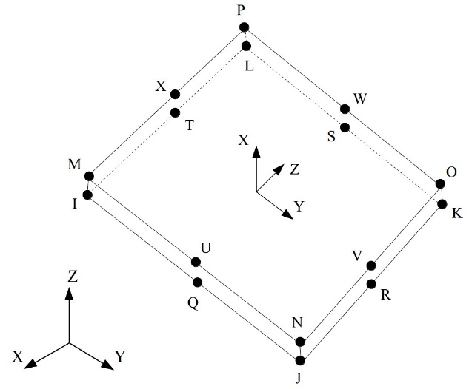
Figure 1. Node locations, geometry, connecvity and the nodal coordinate system of the INTER204 element.

For the elements of the interface, it is defined the interfacial separation as the displacement jump:
δ = u^{TOP} - u^{BOTTOM} (Eq.6)
where, u^{TOP} and u^{BOTTOM} are respectively the displacement of the top surface and the bottom surface of those interface elements according to the local element coordinate system (Figure 2). The local tangent direction and the local normal direction (of the interface) are respectively denoted as t and n.
$δ_{n}=n·δ$ (Eq.7)
$δ_{t}=t·δ$ (Eq.8)
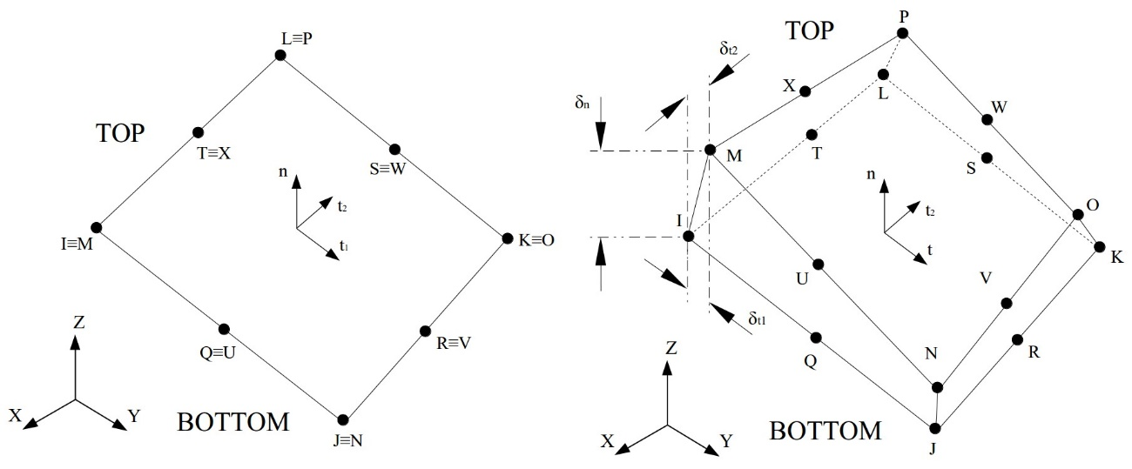
Figure 2. Undeformed interface element on the left and deformed on the right.

An exponential alternative of the CZM model, which was initially proposed by Xu and Needleman [39], involves the following surface potential:
$Φ\left(δ\right)=eσ_{max}\bar{δ_{n}}\left[1-\left(1+Δ_{n}\right)e^{-Δ_{n}}e^{-Δ_{t}^{2}}\right]$ (Eq.10)
where Φ(δ) is the surface potential, e is the Euler number, σ_{max} is the maximum normal traction value at the interface, ${\bar{δ}}_{n}$ is the normal separation across the interface where the maximum normal traction value is obtained with ${\bar{δ}}_{t}=0$, ${\bar{δ}}_{t}$ is shear separation where the maximum shear traction value is reached at $δ_{t}=\left({\sqrt{\left[2\right]}}/2\right){\bar{δ}}_{t}$, $Δ_{n}={δ_{n}}/{\bar{δ_{n}}}$ and $Δ_{t}={δ_{t}}/{\bar{δ_{t}}}$. The material constants σ_{max}, ${\bar{δ}}_{n}$and ${\bar{δ}}_{t}$are inputs of the Exponential Law (Table 1).
Table 1. Material constants to define the exponential CZM model
VARIABLE | EQUIVALENCE | DESCRIPTION
C1 | σ_{max} | Maximum normal interface traction
C2 | $${\bar{δ}}_{n}$$ | Normal separation through the interface with normal traction being the maximum
C3 | $${\bar{δ}}_{t}$$ | Shear separation through the interface with shear traction being the maximum

The traction can be defined as:
$T=\frac{∂Φ\left(δ\right)}{∂δ}$ (Eq.11)
where it is calculated that:
$T_{n}=eσ_{max}Δ_{n}e^{-Δ_{n}}e^{-Δ_{t}^{2}}$ (Eq.12)
for normal traction at the interface, and:
$T_{t}=2eσ_{max}\frac{\bar{δ_{n}}}{\bar{δ_{t}}}Δ_{t}\left(1+Δ_{n}\right)e^{-Δ_{n}}e^{-Δ_{t}^{2}}$ (Eq.13)
for shear traction at the interface.
When it comes to the 3D stress state, tangential or shear separations and the corresponding tractions have two components, respectively δ_{t1} and δ_{t2}, in the element tangential plane, therefore δ_{t} can be obtained as:
$δ_{t}=\sqrt{δ_{t_{1}}^{2}+δ_{t_{2}}^{2}}$ (Eq.14)
And the traction can be defined as:
$T_{t_{1}}=\frac{∂Φ\left(δ\right)}{∂δt_{1}}∧T_{t_{2}}=\frac{∂Φ\left(δ\right)}{∂δt_{2}}$ (Eq.15)
Finally, a correlation analysis was performed between the shear force (F_{shear}) vs displacement (u) curves obtained from the experimental results and those curves obtained from the simulation results, in order to evaluate the goodness of fit between the experimental and simulation data. The procedure followed to perform this comparison has been the one described below. On the one hand, an average F_{shear} vs u curve was obtained for each type of PLA–PA6/sepiolite nanocomposites joins. Each average curve resulted from the interpolation of the experimental data from 5 tested specimens. On the other hand, simulations carried out by using ANSYS software reported the evolution of the shear force versus the applied displacement in the non-recessed end of the specimen (boundary conditions) taking into account defined values ​​of the material constants in the cohesive zone C1, C2 and C3. As result, a virtual F_{shear} vs u curve for each PLA-PA6/sepiolite nanocomposites join was obtained. The data of the average and virtual curves resulting for each PLA-PA6/sepiolite nanocomposite join were treated to obtain a final correlation coefficient (r) as a comparative parameter of the goodness of fit. r was calculated by computing in MATLAB software the Pearson equation [Eq. 15]:
$r_{xy}=\frac{\sum_{i=1}^{n}{\left(x_{i}-\overline{x}\right)\left(y_{i}-\overline{y}\right)}}{\sqrt{\sum_{i=1}^{n}{{\left(x_{i}-\overline{x}\right)}^{2}}}\sqrt{\sum_{i=1}^{n}{{\left(y_{i}-\overline{y}\right)}^{2}}}}$ (Eq.15)
Where x is the experimental shear force, y is the virtual shear force obtained from simulations, $\overline{x}$ is the average experimental shear force and $\overline{y}$ is the average virtual shear force.
3. RESULTS AND DISCUSSION

3.1. Material properties analysis
The mechanical behaviour of the material changes at increasing clay reinforcement. Table 2 shows the impact of the nanoclay on the Young’s modulus (E), tensile strength (σ_{M}) and strain at break (ε_{tB}). The strain at break decreases dramatically (86%) at low sepiolite percentage (PA6-S-1 sample). At higher clay loading ε_{tB} gradually reduces and PA6-S-9 breaks without or barely deformation. Young´s modulus gradually rises with the content of sepiolite up to 90% enhancement when the highest percentage is added (PA6-S-9 sample), which indicates higher stiffness of the material. The value of σ_{M} increases at higher percentage of sepiolite in the nanocomposite samples owing to the great interfacial area of the nanoparticles and the interactions between them and the polymer chains which trigger the transfer of stress to the reinforcing phase as reported by Ray and Okamotor [40].

The SEM images of the specimen’s surfaces after break (Figure 3) confirm the transition from ductile to brittle material after sepiolite reinforcement. In PA6-S-0 and PA6-S-1 the necking decreases significantly before failure. As Callister [41] consider typical of ductile materials, these samples exhibit microcavities (Figure 3D) and irregular fibrous dimples. PA6-S-3 also behave as a ductile material; however, the deformation is limited. On the contrary, in PA6-S-5, PA6-S-7 and PA6-S-9, which break with negligible plastic deformation, several crests appear (Figure 3) indicating where the break has occurred.
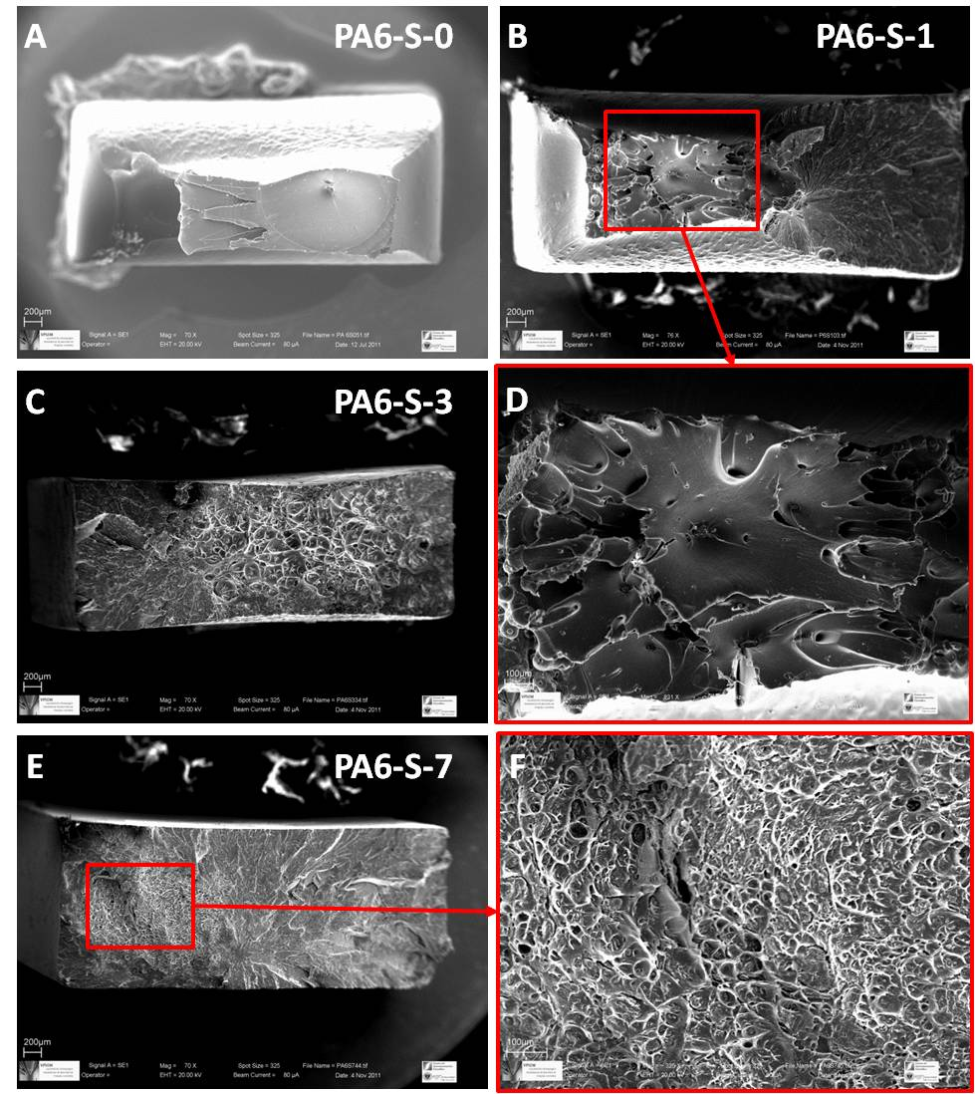
Figure 3. SEM images of the section of break of some PA6/sepilite nanocomposite specimens after being tensile tested.

The crystallinity indices (W_{c}) calculated and the Heat Deflection Temperatures are also summarised in Table 2. According to Fernandez-Barranco et al. [42], the sepiolite fibres locate between the polyamide lamellae, which hinder the nucleation of new polyamide crystals. Therefore, the PA6-S-0 sample (pure PA6) exhibits the highest value of crystallinity and the melting of the samples do not occur at a particular temperature but in a temperature range around Tm. According to the mechanical tests the HDT increases with increasing sepiolite content in the nanocomposites since high stiffness is directly linked to high deflection resistance (63% at 9% sepiolite content). Therefore, higher sepiolite percentage renders a material with improved thermomechanical properties at higher service temperature.

Table 2. Tensile parameters (σ_{M} , ε_{tB} and E), crystallinity index (Wc) and heat deflection temperature (HDT) of pure PA6 and PA6/sepiolite nanocomposites
SAMPLE | σ_{M} (MPa) | ε_{tB} (MPa) | E (MPa) | W_{c} (%) | HDT (°C)
PA6-S-0 | 66.9 | 340 | 893 | 28.97 | 52
PA6-S-1 | 73.2 | 47 | 925 | 29.72 | 58
PA6-S-3 | 76.3 | 36 | 1.06·10³ | 28.08 | 64
PA6-S-5 | 93.0 | 20 | 1.28·10³ | 27.13 | 69
PA6-S-7 | 95.7 | 19 | 1.41·10³ | 26.46 | 76
PA6-S-9 | 103 | 13 | 1.70·10³ | 25.44 | 85

Figure 4 displays the Debye-Scherrer rings from the 2D XRD diffraction analyses of some nanocomposite samples. It consists of concentrical rings, resulting from the intersection of the flat detector with diffraction cones, whose radius is related to a set of crystallographic planes of the tested sample (crystals of both PA6 and sepiolite) satisfying the Bragg diffraction condition. Randomly oriented crystals (or poorly oriented) result in rings with homogeneous spot density (PA6-S-0 and PA6-S-1). At a high 2θ angle, the sample of PA6-S-5 shows an arc (ascribed to an incipient crystal orientation) whose intensity increases at increasing sepiolite content (PA6-S-9 sample). In addition, an additional Debye ring appears at a low 2θ angle in the sample PA6-S-5, which corresponds to the sepiolite crystals. The ring becomes more intense at increasing clay loading, which indicates higher orientation of the sepiolite fibres. Garcia-Lopez et al. [43] proved the dispersion of the sepiolite fibres in the polymer matrix to be related to the orientation of the clay in the samples and the organophilisation of the clay, which reduces the sepiolite–sepiolite interactions and promote the homogeneous dispersion in the polymer. Moreover, the shear during the injection moulding process promotes the orientation of both PA6 crystals and sepiolite fibres. According to these authors, the satisfactory alignment and dispersion of the sepiolite would improve HDT values. The arrangement of the fibrous clay sepiolite into PA66 matrix has been determined by Fernandez-Barranco et al. [42] as a reticulated semi-crystalline arrangement in which the higher the percentage of sepiolite in the sample, the more reticulated the resulting nanocomposite is. In addition, the formation of chemical bonding between the organic polymer chains and the inorganic phyllosilicate has been reported by Okada and Usuki [1] to be essential to achieve this reinforcing effect.

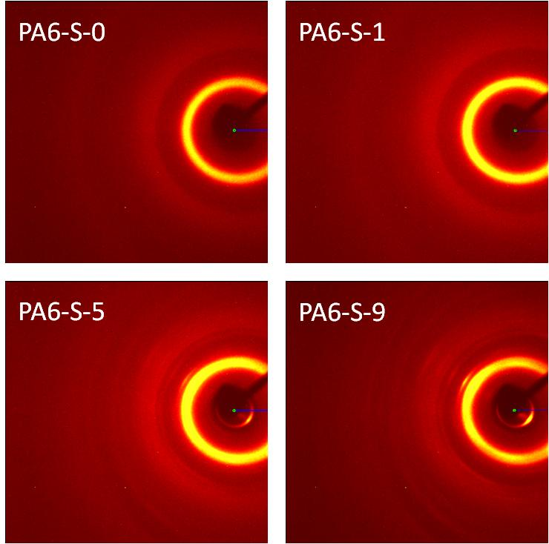
Figure 4. SEM images from the failure section of some PA6/sepiolite nanocomposite specimens after being tensile tested.

In PA6/sepiolite nanocomposites the sepiolite rods locate perpendicular to the PA6 lamellae by means of H-bonds, breaking the H-bonds between abutting lamellae, but establishing new ones between the between the amide groups of the PA6 and the silane groups of the sepiolite. They have been reported by Yebra-Rodriguez et al. [44] as promoters of the reinforcement of the system because the sepiolite nanoparticles do not act as inclusions that could decrease the tensile strength (σ_{M}) values, but rather as reinforcement. The 2D patterns (Figure 4) were converted into their equivalent 1D powder diffractograms (e.g. 2θ scans, Figure 5) by using XRD2DScan software. In PA6/sepiolite nanocomposites the polymer chain can maintain the typical extended structure of the thermodynamically stable α structure at higher sepiolite loadings since the morphology of the sepiolite does not require the polymer chain dimensions to accommodate the crystallographic dimensions of the fibrous clay.
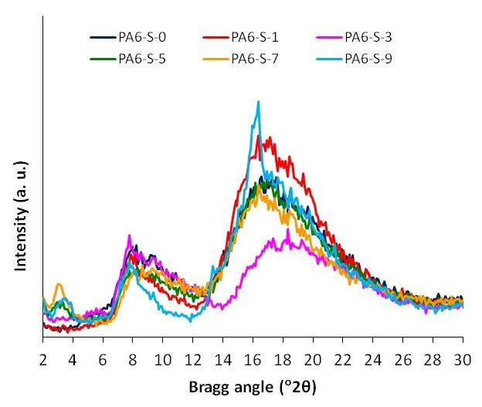
Figure 5. Diagrams 1D of X-ray diffraction obtained from 2D patterns. The peak with values 2 - 4 º 2θ is associated to the diffraction of the plane (110) of the sepiolite. The reflections corresponding to the polymorphs α (planes (100) and (010) + (110)) and γ (plane (001)) appear in the area of values 14 - 24 º2θ.

Optical analysis showed that raw PLA was an excellent material to be used as transparent part in TLWT however only PA6-S-XCCA nanocomposites presents appropriate absorbent properties to be used as absorbent part (Table 3). Table 4 shows a summary of crucial properties in terms of TLWT of those materials (PA6-S-XCCA, PLA, sepiolite) which were involved in the welding trials performed in this work.
Table 3. Optical properties of materials at 980 nm
Material | R (%) | T (%) | A (%)
PA6-S-0 | 5.04±1.11 | 36.73±1.18 | 58.22±1.38
PA6-S-0CAA | 9.15±0.12 | 2.52±0.23 | 88.33±0.31
PA6-S-1 CAA | 9.38±0.16 | 2.18±0.15 | 88.43±0.23
PA6-S-3 CAA | 9.84±0.10 | 2.63±0.11 | 87.52±0.16
PA6-S-5 CAA | 10.51±0.92 | 2.57±0.23 | 86.91±0.84
PA6-S-7 CAA | 9.51±0.48 | 2.53±0.06 | 87.95±0.50
PA6-S-9 CAA | 9.41±0.33 | 2.51±0.14 | 88.08±0.24
PLA | 0.11±0.01 | 90.62±0.19 | 9.27±0.18

Table 4. Volumetric and thermal properties of studied materials
Material | X | Ø | Tm  (°C) | λ  (W/(m·K)) | c  (J/(g·K)) | v  (m³/kg)
PA6-S-0 | 0 | 0 | 223.2 | 0.27 | 1.18 | 8.49·10⁻⁴
PA6-S-1 | 0.01 | 0.005 | 224.0 | 0.27 | 1.19 | 8.44·10⁻⁴
PA6-S-3 | 0.03 | 0.014 | 223.5 | 0.27 | 1.21 | 8.35·10⁻⁴
PA6-S-5 | 0.05 | 0.024 | 221.8 | 0.27 | 1.23 | 8.26·10⁻⁴
PA6-S-7 | 0.07 | 0.034 | 222.1 | 0.28 | 1.25 | 8.17·10⁻⁴
PA6-S-9 | 0.09 | 0.044 | 221.6 | 0.28 | 1.27 | 8.08·10⁻⁴
Sepiolite | - | 0 | - | 1.03 | 2.17 | 3.95·10⁻⁴
PLA | - | 1 | 175.0 | 0.12 | 1.63 | 8.06·10⁻⁴

3.2. Welding analysis
Table 5 presents the results of the strength of the welds in terms of F_{shear}MAX. Shear testing results showed an initial decrease of the strength for nanofiller contents lower than 1 wt% nevertheless from this point forward the trend overturns to increase up to reach a F_{shear}MAX 39% upper than reference weld (PA6-S-0CAA/PLA) at a sepiolite loading of 9 wt%. Peeling testing results presents also similar trend, initially weld strength decreases up to reach a threshold at 1% wt of loading content and from this point forward M_{peeling}MAX increases up to reach a M_{peeling}MAX 23% higher than reference weld at a sepiolite loading of 9 wt%. It is remarkable that when the nanofiller content reaches around 5 wt%, F_{shear}MAX and M_{peeling}MAX accomplish values similar to those presented by PA6-S-0CAA/PLA. As described in Navas-Martos et al. [34], this behaviour can be explained through two compensative effects based on the PA6/sepiolite nanocomposites mechanical and the influence of fillers in the TLW process. On the one side, PA6/sepiolite nanocomposites tensile strength and Young´s Modulus increase with sepiolite content. On the other side, Navas-Martos et al. [34] expose that the sepiolite load can reduce the effectiveness of the laser welding process with barely changes in nanocomposite thermal properties. According to the results (Tables 2, 3 and 4), the exceptional properties of PA6/sepiolite nanocomposites with a sepiolite content upper 5 wt% come to counterbalance the loss of effectiveness in the TLW process to result in higher performance welds as the sepiolite content increases.
Table 5. Mechanical properties of joining
JOINING | F_{shear}MAX (N) | M_{peeling}MAX (N·m)
PA6-S-0 CAA/PLA | 209.60±19.41 | 812.84±38.21
PA6-S-1 CAA/PLA | 174.67±19.35 | 605.14±62.72
PA6-S-3 CAA/PLA | 190.87±12.57 | 760.15±20.84
PA6-S-5 CAA/PLA | 197.33±2.72 | 748.55±11.67
PA6-S-7 CAA/PLA | 230.87±5.63 | 870.01±26.18
PA6-S-9 CAA/PLA | 263.47±3.85 | 904.51±27.99

SEM was performed to study the cross-section of the weld before being mechanically tested and to analyse the weld beam surfaces after being mechanically separated. SEM cross-section images (Figure 6a) elucidated that weld seams were produced due to the anchoring generated by the interpenetration between phases. Additionally, SEM images obtained from separated samples exposed a width of the weld seams between 2.6-3.6 mm and the most significant effects in those less resistant samples tested by shear testing (Figure 6b). Figure 6c shows FTIR maps of some PLA and PA6-S-9CAA samples (from the weld PA6-S-9CAA/PLA after being tested) performed through monitoring the strong bands at the range 1535-1638 cm⁻¹ which, as mentioned in Charles et al. [45], is the typical amide II band/CH₂ asymetric deformation in PA6 (top samples) and at 1085-1180 cm⁻¹ which, as mentioned in Riba et al. [46], is the typical asymmetrical stretching C-O-C in PLA (samples from the bottom row). The virtually homogeneous distribution of the bands in the maps means there were no traces of one material in the other what confirms previous SEM results: the welds take place because of the interpenetration of phases without the mixing of the molten material

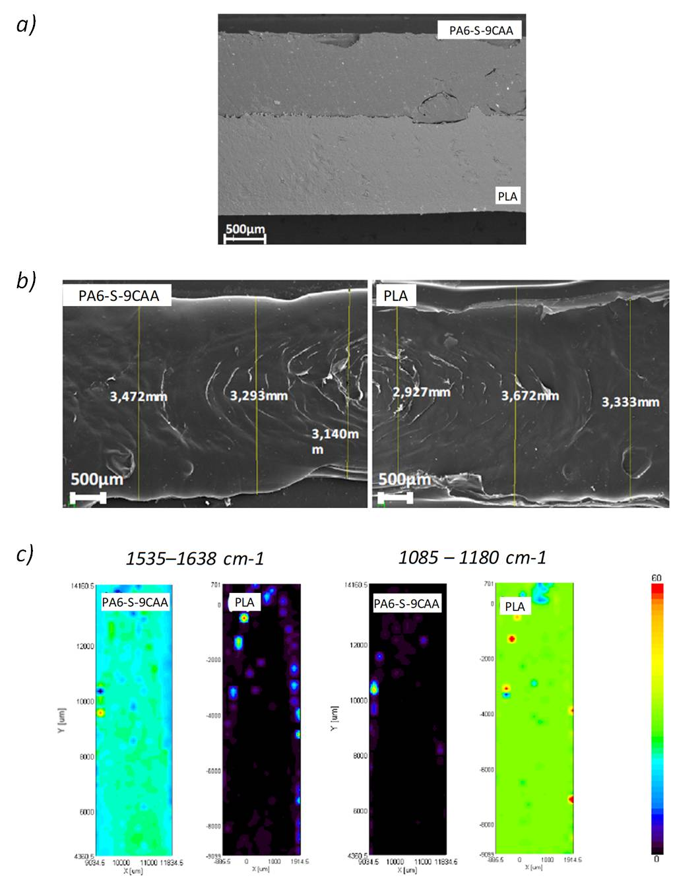
Figure 6. a) SEM images at a zoom of 209X of the cross section of the welded samples of PLA / PA6-S-9CCA; b) Weld bead width of the PA6-S-9CAA / PLA system measured after shear tests; c) Results of the FTIR mapping of some samples of selected PA6-S-9CAA/PLA systems after being submitted to the shear test.

3.3. Tensile simulations
After being processed by ANSYS software to get a suitable tensile model to carry out the subsequent tensile simulations, the final 3D design of the tensile specimen resulted as it is showed in Figure 7a. This complete 3D model (discretised geometry) was subjected to the required boundary conditions to be applied to carry out a satisfactory tensile simulation (Figure 7b) by using ANSYS software again. As result it was performed 5 “virtual” tensile strain–stress curves (one per every experimentally tested specimen) for each type of nanocomposite. Finally, curve data were processed through linear interpolation by means of MATLAB software to get an average “virtual” tensile strain–stress curve (mean curve) for each nanocomposite. The resulting mean curves were considered as the data which defined the mechanical nanocomposites behaviour in terms of simulations. Figure 7c shows the 5 true tensile strain–stress curves of PA6-S-9CAA specimens and their corresponding mean curve. The average curves of rest of the studied nanocomposites determined the same clear non-linear elastic behaviour of the material showed in the Figure 7c for of PA6-S-9CAA.

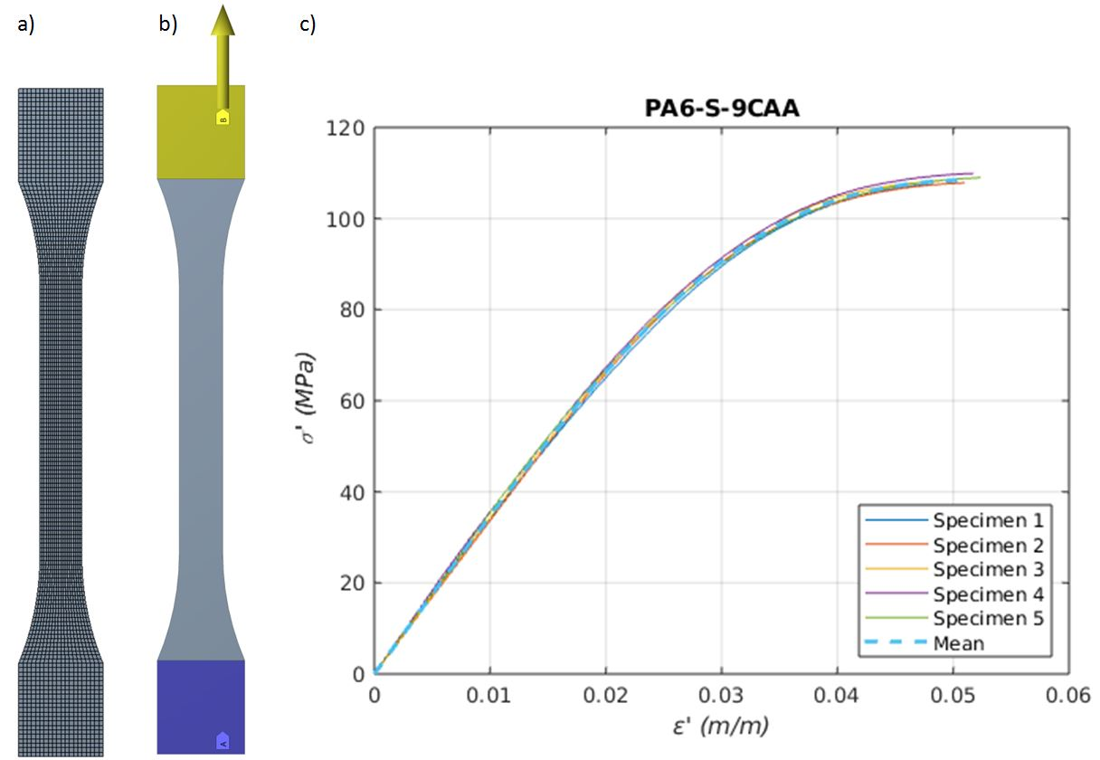
Figure 7. a) 3D model for tensile tests; b) boundary conditions; c) resulting curves from tensile test simulation carried out for PA6-S-9CAA nanocomposite.

3.4. Shear simulations
Once established the mechanical behaviour for the nanocomposites it was determined the necessary constants to define the delamination behaviour of the welding interface between plates according to the exponential CZM model. Initially, a suitable 3D CAE design of the welded specimen was prepared by processing the computer-aided design (CAD) of the final welding system by using ANSYS software. Figures 8a and 8b show the corresponding discretised model. Figure 8c indicates the boundary conditions applied to simulate by using selected values of the material constants (C1, C2 and C3), where a conformal mesh of elements was fixed in the area corresponding to the welding since a coincidence of nodes was mandatory in the initial time in order to get a proper delamination of the interface during simulation.
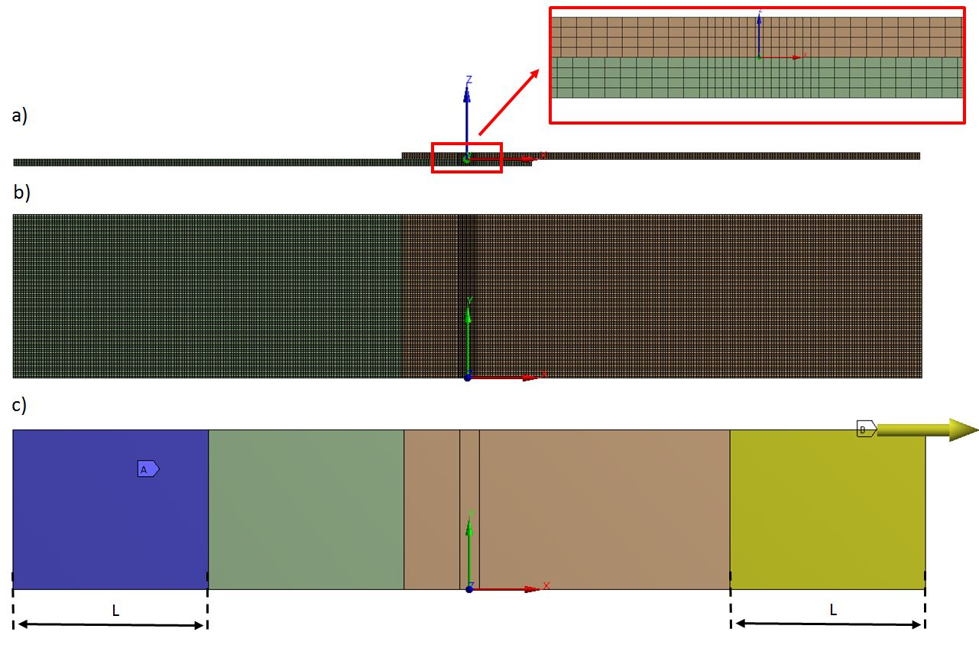
Figure 8. a) Lateral view of welding model and cohesive zone zoom; b) top view of the welding model; c) boundary conditions.

As result, on the one hand, the equivalent stress can be post-processed to get the corresponding shear force in the welding zone in any instant during the simulation. Figure 9 shows the equivalent stress for the instant prior to the breakage, at which time the maximum shear force, for PA6-S-9CAA/PLA welding. As a singularity, stress concentration can be observed in those specimen regions close to the exterior border of the cohesive zone. On the other hand, it was performed the virtual curves which define the evolution of the shear force with respect to the displacement of the clamp for each nanocomposite. Figure 10 shows the virtual shear force-displacement curve obtained for the PA6-S-9CAA/PLA welding. In addition, data from the experimentally tested welded specimens and their corresponding average curves (mean curves) are also represented in the same graphic. In this specific case a weak similarity between the experimental and virtual data can be easily observed which means a bad correlation (r=0.53) and new validations by using alternative C1, C2 and C3 coefficient values were mandatory until getting correlation values of r close to 1.

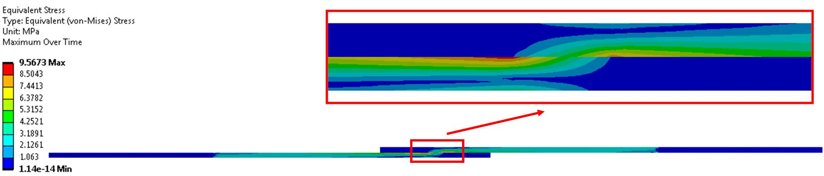
Figure 9. Maximum equivalent Von-Mises stress over time into symmetry plane for the PA6-S-9CAA/PLA welding.

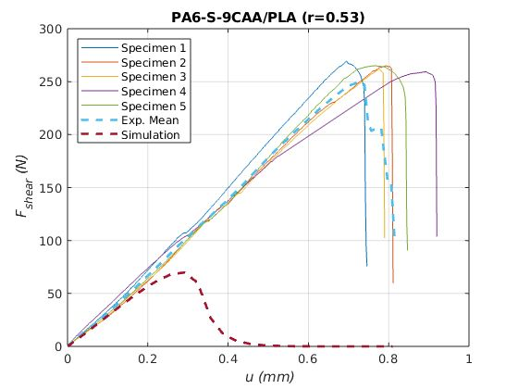
Figure 10. Clamp displacement vs shear force for the PA6-S-9CAA/PLA.
By using the reverse engineering process, the optimum values of the material constants (C1, C2 and C3) that best fit the experimental tests were obtained through simulation and correlation analysis cycles. Proceeding in the same way with the rest of nanocomposites, the material constants of the cohesive zone were fitted for every type of material resulting in the values listed in Table 6, where it is also denoted the value of the correlation coefficients.
Table 6. Material Constants-Exponential Law for the shear test and correlation coefficient
WELDING | C1 - $σ_{max} [MPa]$ | C2 - $δ_{n} [mm]$ | C3 - $δ_{t} [mm]$ | r
PA6-S-0 CAA/PLA | 5.20 | 0.07 | 0.33 | 0.99
PA6-S-1 CAA/PLA | 1.75 | 0.25 | 0.50 | 0.99
PA6-S-3 CAA/PLA | 1.65 | 0.35 | 0.61 | 0.97
PA6-S-5 CAA/PLA | 1.90 | 0.30 | 0.56 | 0.98
PA6-S-7 CAA/PLA | 3.80 | 0.16 | 0.50 | 0.98
PA6-S-9 CAA/PLA | 4.50 | 0.13 | 0.41 | 0.99
Figure 11 shows the behavior of the studied weldings in terms of described by the shear. On the one hand, the evolution of the 5 experimentally tested specimens and their corresponding mean (experimental mean curve) calculated by interpolation is represented in each graph. On the other hand, each resulting force–displacement curve (simulation curve) obtained from simulations was overlapped on the previous graphs to get a suitable visual comparison. In addition, the correlation value between these curves is also indicated. The values of r and the similarity between experimental and simulation curves confirms that through simulation of finite elements (FEM) it has been shown that there is an interlaminar fracture model known as CZM that governs the separation behavior of the plates during the shear test.
In summary, it can be affirmed the existence of a fairly similar mechanical behavior of the cohesive zone in simulation with respect to the welding experimentally tested during the stage of delamination of the interface. Moreover, according to the Figure 11 it is only after the complete fracture of the weldings when any of the proposed virtual models differs from the experimental mean curves.

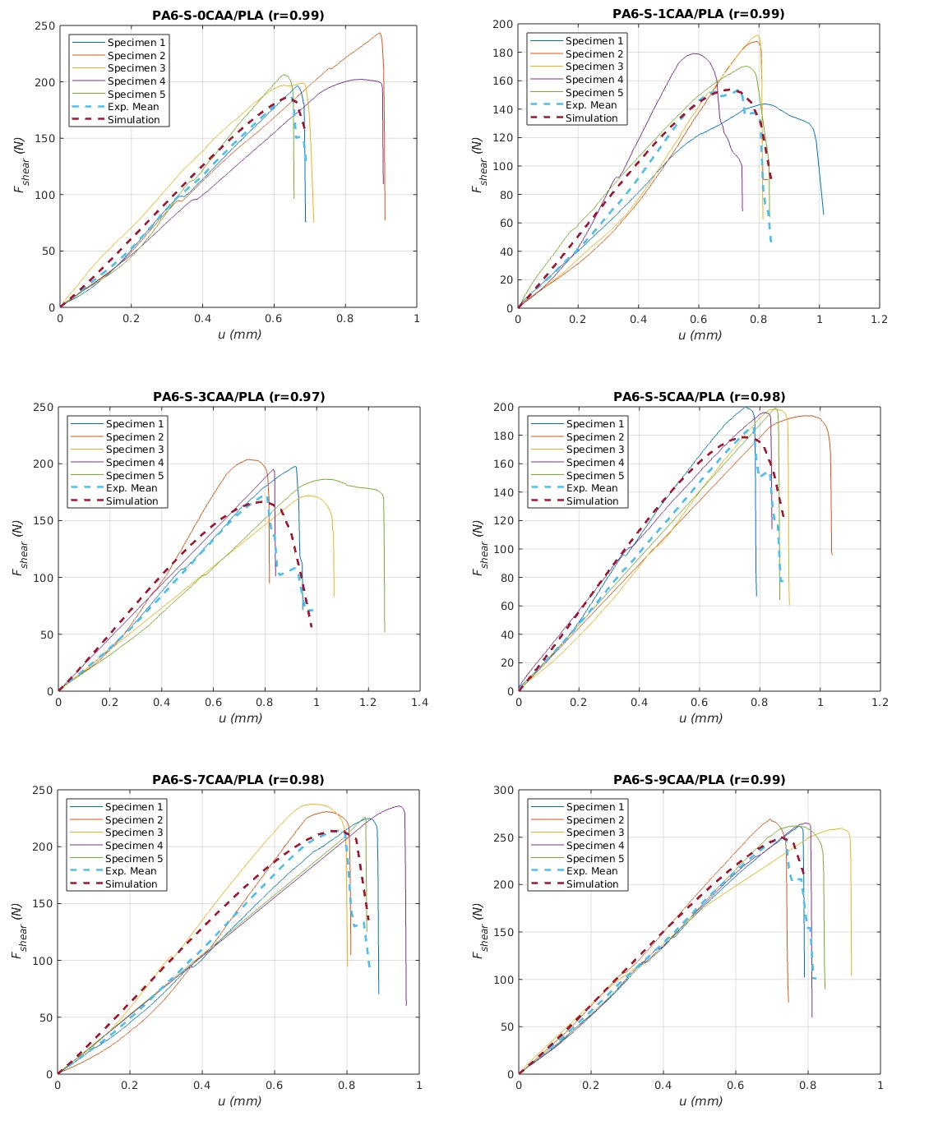
Figure 11. Clamp displacement vs shear force for each nanocomposite.

4. CONCLUSIONS

PA6/sepiolite nanocomposites were manufactured by using the fibrous clay sepiolite as reinforcing agent at different percentages. The mechanical analyses confirm the transition from ductile to brittle material at higher clay loading, and the materials break with negligible plastic deformation. Young´s modulus gradually rises with the content of sepiolite up to 90% enhancement when the highest percentage is added, which indicates higher stiffness of the material. The arrangement between the polymer chains and the clay fibres obstruct the nucleation of novel polyamide crystals and the melting of the samples do not occur at a particular temperature but in a temperature range around Tm. HDT values also increase at higher sepiolite content, which makes it a suitable material for use at higher temperatures. Higher orientation of PA6 crystals and sepiolite fibres at increasing filler content has been observed on the basis of XRD. The good dispersion and alignment of the sepiolite would improve HDT values. Moreover, the PA6 chains maintain the α structure at higher clay percentage since the sepiolite do not require the crystallographic accommodation of the polymer chains to the dimensions of the clay fibres.

Optical and TLW trials results indicated that it is mandatory to add a minimum load of CAA to the PA6/sepiolite nanocomposites in order to provide them with the suitable absorbent properties to carry out an efficient TLW process with PLA. The shear tests clarified that, in terms of welding performance, it is not justified to add sepiolite percentages below 5%, since such low sepiolite content even decreases the strength of the weld. Nevertheless, for percentages greater than 5 wt% the welding strength enhances as the sepiolite content rises until reaching the maximum resistance for 9 wt% of sepiolite. SEM images and FTIR maps reveal 2.6-3.6 mm wide weld seams generated due to the interpenetration of phases without the mixing of the molten material.

Nanocomposites strain–stress average curves obtained by simulation determined a clear non-linear elastic behaviour of the studied materials. Based on both this mechanical behaviour and the material constants of the cohesive zone calculated, an optimum predictive CZM model in terms of mechanical response against shear forces was defined for every type studied welding. Correlation analysis reported an excellent goodness of fit between the experimental and simulation data, elucidating the propriety of the proposed models to predict mechanical behaviour of the welding.

5. ACKOWLEDGEMENTS

The authors mainly thank the RNM-325 and TEP-138 research groups (CICE, Junta de Andalucía, Spain), ANDALTEC Technology Center (Spain) and the CICT of University of Jaen (Junta de Andalucía, MINECO, FEDER) for the financial, technical and human support received to carry out this research.

6. REFERENCES

[1] Okada A, Usuki A. Twenty years of polymer-clay nanocomposites. Macromolecular Materials and Engineering 2006; 291:1449-76. https://doi.org/10.1002/mame.200600260
[2] Ali F, Ullah H, Ali Z, Rahim F, Khan F, Rehman ZU. Polymer-clay nanocomposites, preparations and current applications: a review. Current Nanomaterials 2016;1:1-13. 10.2174/2405461501666160625080118
[3] Petersen E.N., Arisman, K. Chapter Engineering Thermoplastics in Applied Polymer Science: 21st Century. 2000, 177-196. https://doi.org/10.1016/B978-008043417-9/50012-X
[4] Bunn CW, Garner EV. The crystal structures of two polyamides ('nylons'). Proceedings of the Royal Society. London. A. 1947;189:39-68.
https://doi.org/10.1098/rspa.1947.0028
[5] Murthy NS. Hydrogen bonding, mobility, and structural transitions in aliphatic polyamides. Journal of Polymer Science Part B: Polymer Physics 2006;44:1763-82. https://doi.org/10.1002/polb.20833
[6] Fukushima K, Tabuani D, Camino G. Poly (lactic acid)/ clay nanocomposites: effect of nature and content of clay on morphology, thermal and thermo-mechanical properties. Materials Science and Engineering. C. 2012;32:1790-95.
https://doi.org/10.1016/j.msec.2012.04.047
[7] Fernandez-Barranco C, Yebra-Rodriguez A, La Rubia-Garcia MD, Navas-Martos, FJ, Alvarez-Lloret P. Mechanical and crystallographic properties of injection molded polyamide 66/sepiolite nanocomposites with different clay loading. Polymer Composite 2015;36:2326-33. https://doi.org/10.1002/pc.23146
[8] Yebra-Rodriguez A, Alvarez-Lloret P, Cardell C, Rodriguez-Navarro AB. Crystalline properties of injection molded polyamide-6 and polyamide 6/montmorillonite nanocomposites. Applied Clay Science 2009;43:91-7.
https://doi.org/10.1016/j.clay.2008.07.010
[9] Da Paz RA, Leite AMD, Araujo EM, Medeiros VN, De Melo TJA, Pessan LA. Mechanical and thermomechanical properties of polyamide 6/Brazilian organoclay nanocomposites. Polimeros 2016;26:52-60. http://dx.doi.org/10.1590/0104-1428.1748
[10] Moskvitin GV, Polyakov AN, Birger EM. Laser welding of plastics (review). Welding International 2013;27:725-34. 10.1080/09507116.2012.753282
[11] Visco AM, Brancato V, Torrisi L, Cutroneo M. Employment of Carbon Nanomaterials for Welding Polyethylene Joints with a Nd: YAG Laser. International Journal of Polymer Analysis and Characterization 2014;19:489-99.
10.1080/1023666X.2014.921108
[12] Nakhaei MR, Mostafa-Arab NB, Naderi G. Application of response surface methodology for weld strength prediction in laser welding of polypropylene/clay nanocomposite. Iran. Polymer. J. 2013;22:351-60.
https://doi.org/10.1007/s13726-013-0134-6
[13] Kendall K. Transition between Cohesive and Interfacial Failure in a Laminate. Proceedings of the royal society A. 1975;344:287-302.
https://doi.org/10.1098/rspa.1975.0102
[14] Piggott MR. A new model for interface failure in fibre-reinforced polymers. Composites Science and Technology 1995;55:269-76.
https://doi.org/10.1016/0266-3538(95)00103-4
[15] Darveaux R, Reichman C, Islam N. Interface Failure in Lead Free Solder Joints. 56th Electronic Components and Technology Conference 2006.
10.1109/ECTC.2006.1645763
[16] Xu W, Wei Y. Strength and interface failure mechanism of adhesive joints. International Journal of Adhesion & Adhesives 2012;34:80-92.
https://doi.org/10.1016/j.ijadhadh.2011.12.004
[17] Lin J, Ma N, Lei Y, Murakawa H. Investigation on Interface Failure and Shear Strength of CMT Brazed Lap Joint of Dissimilar Materials. Advanced Materials Research 2013;629:131-8. https://doi.org/10.4028/www.scientific.net/AMR.629.131
[18] Taljera R, Varna J. Modeling Damage, Fatigue and Failure of Composite Materials. Woodhead Publishing Series in Composites Science and Engineering 2016.
[19] Li L, Sun L, Dai Z, Xiong Z, Huang B, Zhang Y. Experimental investigation on mechanical properties and failure mechanisms of polymer composite-metal hybrid materials processed by direct injection-molding adhesion method. Journal of Materials Processing Technology 2019;263:385-95.
https://doi.org/10.1016/j.jmatprotec.2018.08.039
[20] Hansen-Dörr AC, De Borst R, Henning P, Kästner M. Phase-field modelling of interface failure in brittle materials. Computer Methods in Applied Mechanics and Engineering 2019;346:25-42. https://doi.org/10.1016/j.cma.2018.11.020
[21] Fujimoto T, Akashi T, Nishioka T. Crack-tip Deformation Behavior under Nonlinear and Dynamic Large Deformation of Metallic Materials. Advances on Computational Engineering and Sciences 2000;II:1860-65.
[22] Trädegård A, Nilsson F, Östlund S. FEM-remeshing technique applied to crack growth problems. Computer Methods in Applied Mechanics and Engineering 1998;160:115-31. https://doi.org/10.1016/S0045-7825(97)00287-9
[23] Shet C, Deng X. Finite element analysis of the orthogonal metal cutting process. Journal of Materials Processing Technology 2000;105:95-109.
https://doi.org/10.1016/S0924-0136(00)00595-1
[24] De Carvalho NV, Krueger R, Mabson GE, Deobald LR. Combining Progressive Nodal Release with the Virtual Crack Closure Technique to Model Fatigue Delamination Growth Without Re-meshing. Structures. Structural Dynamics and Materials Conference 2018. https://doi.org/10.2514/6.2018-1468
[25] Wei Y, Hutchinson JW. Interface strength, work of adhesion and plasticity in the peel test. International Journal of Fracture 1998;93:315-33. 10.1023/A:1007545200315
[26] Alfano G, Crisfield MA. Finite element interface models for the delamination analysis of laminated composites: mechanical and computational issues. International journal for numerical methods in engieering 2001;50:1701-36.
https://doi.org/10.1002/nme.93
[27] Valoroso N, Champaney L. A damage-mechanics-based approach for modelling decohesion in adhesively bonded assemblies. Engineering Fracture Mechanics 2006;73:2774-801. https://doi.org/10.1016/j.engfracmech.2006.04.029
[28] Yan Y, Shang F. Cohesive zone modeling of interfacial delamination in PZT thin films. International Journal of Solids and Structures 2009;46:2739-49.
https://doi.org/10.1016/j.ijsolstr.2009.03.002
[29] Dandekar CR, Shin YC. Multi-scale modeling to predict sub-surface damage applied to laser-assisted machining of a particulate reinforced metal matrix composite. Journal of Materials Processing Technology 2013;213:153-60.
https://doi.org/10.1016/j.jmatprotec.2012.09.010
[30] Wu X, Lian Q, Li D, Jin Z. Tilting separation analysis of bottom-up mask projection stereolithography based on cohesive zone model. Journal of Materials Processing Technology 2017;243:184-96. https://doi.org/10.1016/j.jmatprotec.2016.12.016
[31] Gliszczynski A, Samborski S, Wiacek N, Rzeczkowski J. Mode I Interlaminar Fracture of Glass/Epoxy Unidirectionsl Laminates. Part II. Numerical Analysis. Materials 2019;12(10):1604. 10.3390/ma12101604
[32] Mehta RH. Physical constants of various polyamides: polyamide 6, polyamide 6.6, polyamide 6.10 and polyamide 12. Brandrup, J., Immergut, E.H., Grulke, E.A.(Eds.). Polymer Handbook, John Wiley & Sons; 1999, V121-V133. 10.1002/0471532053.bra035
[33] Rodriguez-Navarro AB. XRD2DScan: new software for polycrystalline materials characterization using two-dimensional X-ray diffraction. Journal of Applied Crystallography 2006;39:905-9. https://doi.org/10.1107/S0021889806042488
[34] Navas-Martos FJ, Yebra-Rodriguez A, La Rubia MD. Laser transmission welding of poly(lactic acid) and polyamide 66/sepiolite nanocomposites. Journal of Applied Polymer Science. Wiley Periodicals 2018;135(36):46638. https://doi.org/10.1002/app.46638
[35] Midttømme K, Roaldset E, Aagaard P. Thermal conductivity of selected claystones and mudstones from England. Clay Minerals 1998;33:131-45. 10.1180/000985598545327
[36] Çelik–Karakaya M, Karakaya N, Cingilli–Vural H. Thermal Properties of Some Turkish Peloids and Clay Minerals for Their Use in Pelotherapy. Geomaterials 2016;6:79-90. 10.4236/gm.2016.64007
[37] Wen J. Heat Capacities of Polymers. Physical Properties of Polymers Handbook 2007;C9:145-54.
[38] Chen H, Ginzburg VV, Yang J, Yang Y, Wei L, Huang Yan et al. Thermal conductivity of polymer-based composites: Fundamentals and applications. Progress in Polymer Science 2016;59:41-85. https://doi.org/10.1016/j.progpolymsci.2016.03.001
[39] Xu X-P, Needleman A. Numerical simulations of fast crack growth in brittle solids. Journal of the Mechanics and Physics of Solids 1994;42:1397-434.
https://doi.org/10.1016/0022-5096(94)90003-5
[40] Ray SS, Okamoto M. Polymer/layered silicate nanocomposites: a review from preparation to processing. Progress in Polymer Science 2003;28:1539-641.
https://doi.org/10.1016/j.progpolymsci.2003.08.002
[41] Callister WD. Materials Science and Engineering: An Introduction, 8th Edition 2009.
[42] Fernandez-Barranco C, Koziol AE, Drewniak M, Yebra-Rodriguez A. Structural characterization of sepiolite/polyamide 6,6 nanocomposites by means of static and dynamic thermal methods. Applied. Clay Science 2018;153:154-60
https://doi.org/10.1016/j.clay.2017.12.025
[43] Garcia-Lopez D, Fernandez JF, Merino JC, Santaren J, Pastor JM. Effect of organic modification of sepiolite for PA 6 polymer/organoclay nanocomposites. Composites Science and Technology 2010;70:1429-36. 10.1016/j.compscitech.2010.05.020
[44] Yebra-Rodriguez A, Fernandez-Barranco C, La Rubia MD, Yebra A, Rodriguez-Navarro AB, Jimenez-Millan J. Thermooxidative degradation of injection moulded sepiolite/polyamide 66 nanocomposites. Mineralogical Magazine 2014;78:1227-39.
10.1180/minmag.2014.078.5.09
[45] Charles J, Ramkumaar GR, Azhagiri S, Gunasekaran SJ. FTIR and Thermal Studies on Nylon-66 and 30% Glass Fibre Reinforced Nylon-66. E-Journal of Chemistry 2009;6:23-33. https://doi.org/10.1155/2009/909017
[46] Riba JR, Cailloux J, Cantero R, Canals T, Maspoch ML. Multivariable methods applied to FTIR: A powerful technique to highlight architectural changes in poly(lactic acid). Polymer Testing 2018;65:264-9.
https://doi.org/10.1016/j.polymertesting.2017.12.003

